UPPWISE INDIA

www.uppwise.com



**Quaterly Development Planning**

**Q4-2023**

**Feature Title:**

Graphical change to the Risk Matrix

**Priority:**

Medium

**Submitted By:**

SPM

**Target Users:**

Standard Product Users

**Feature Description:**

The proposed feature involves enhancing the visual representation of the Risk Matrix by addressing the asymmetry caused by varying lengths of impact names. The current design results in columns of different widths, leading to a visually inconsistent display. The proposed adjustment aims to create a more aesthetically pleasing and user-friendly Risk Matrix.

**Acceptance Criteria:**

**Create the columns all the same width as the largest column.**

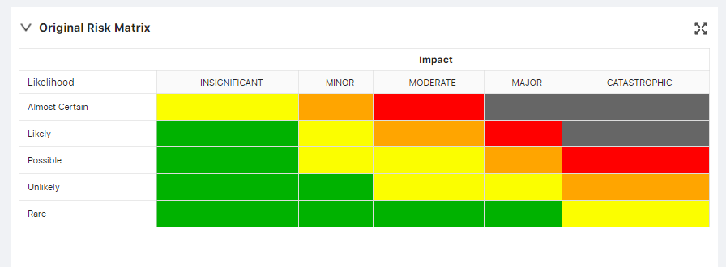

**Feature Benefits:**

**Enhanced User Experience:**

Users benefit from a more visually pleasing and symmetrical Risk Matrix, improving the overall user experience.

**Improved Clarity and Interpretation:**

Equal column widths contribute to clearer data presentation, aiding users in understanding and interpreting risk information effectively.

**Professional Aesthetics:**

The graphical adjustment lends a professional and polished appearance to the Risk Matrix, enhancing the overall aesthetics of the risk management interface.

**Consistent Display Across Devices:**

The feature ensures consistent display and user experience across various devices and screen sizes.